# Bing Bar Human Interface Guide

This document describes design considerations and standards for Bing Bar apps. Use this document to understand how users benefit from Bing Bar apps, what’s possible within a Bing Bar app, and which design patterns are most appropriate within Bing Bar apps. For technical information about implementing Bing Bar apps, see *Bing Bar App Developer’s Guide*.

## Bing Bar Apps

The Bing Bar team built Bing Bar based on this mission statement: "We want the toolbar to be useful, unobtrusive, and anticipative. It serves your needs, gets out of the way when you don't need it, and gives you little magical moments when it presents you with information." Bing Bar apps provide quick, at-a-glance access to information, entertainment, or assistance while the user also does other activities on the web.

The Bing Bar app platform lets partners extend Internet Explorer with rich, interactive apps and tools. Unlike a web page, the Bing Bar travels with the user. This means apps can be aware of the user’s activities and intentions. This new app platform resides between traditional, static links found on traditional browser toolbars, and the full presentation of a web site visit. A Bing Bar app has new tools to determine a user’s goal, including access to data such as the browser URL, DOM, and search history that it can use to determine the user’s intent, help accomplish the user’s goal, or send the user to a web page. Bing Bar apps can help users stay connected to personal web services, and stay informed about topics of interest.

## User Experience Guidelines

This section describes how Bing Bar apps offer value at every step of user interaction.

### Arc of disclosure

Bing Bar apps guide the user through a path (or arc) of growing information disclosure. Starting with the app button and ending with the app's parent web site (if applicable), each step of the Bing Bar app experience reveals more information to the user. Design your app to provide value at every level of interaction.

The arc of disclosure of a Bing Bar app begins with a dynamic button image which might convey information such as the state of a user’s account on a web site, including an overlay of text or graphics that provide visual cues when new information is available. For example, the weather app image changes to reflect current weather conditions.



*Figure: Button image showing current weather conditions*

A single glance might satisfy the user, or the user might hover over the button to reveal a descriptive infotip that provides more details. The weather app uses the infotip to describe current weather conditions in more detail.

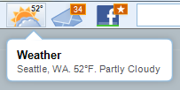

*Figure: Infotip describing weather conditions in more detail*

The infotip can work in conjuction with the button’s image and indicator. In this example, the indicator signals a weather alert, while the infotip describes how to interpret the indicator and get more specific information.

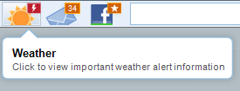

*Figure: Infotip describing button indicator and outcome of a button click*

Clicking the button opens the app wing, without navigating away from the current web page. After interacting with the app wing, the user might click an element in the wing that launches a detailed web page in the browser window. Throughout this process, from the button image to the web page, each interaction reveals more information, with minimal user interaction.

This table describes each UI element of a Bing Bar app across the arc of disclosure.

|  |  |  |
| --- | --- | --- |
| **UI Element** | **Use frequency** | **Remarks** |
| Button image and/or state indicator | 20+/day | Can contain visual cues about dynamic content, so the user can determine useful information just by glancing at a button. |
| Infotip | 5+/day | Can provide more details about the meaning of a dynamic button’s visual state. |
| Alert | Varies | Can alert the user to app state or provide contextual information. May include interactive elements such as buttons or links. |
| Wing UI | 1-3/day | Can engage user for a minute or two, providing a productive, useful, or entertaining set of options that may induce the user to click through to a web site. |
| Web site | 2-3/wk | Can be a specific page the user has sought using the Bing Bar app. |

### User interface principles

These principles guide the design of every successful Bing Bar app.

#### Inductive, at-a-glance applications

Bing Bar apps implement an inductive user interface to provide at-a-glance information and usability. An app should perform a single, easy-to-understand task. The user should not have to deduce the purpose of an app UI that is overloaded with text and overlapping tasks. App designs should present the app purpose and function with simplicity and clarity. For information about inductive user interfaces, see:

http://msdn.microsoft.com/en-us/library/ms997506.aspx

#### Mental overhead

A Bing Bar app saves time for users by displaying only essential information at the right time. When the user has a well-designed app, there’s no need to keep multiple tabs open, or navigate to favorite sites to get personalized information. The goal is to design apps that reduce mental overhead by presenting visual metaphors instead of text, enabling simpler tasks within the Bing Bar app, and presenting users with a manageable number of sensible options, rather than an overwhelming palette of complex features. Visual experiences that employ see-and-point interfaces and immediate visual feedback are ideal ways Bing Bar app designers can further reduce the mental overhead of a modern web site. For example, the mail app provides an easy-to-understand user interface that uses a standard design pattern. With a glance, the user knows if new email has arrived. The app is not overload with a folders view or a composition canvas.

#### Information hierarchy

Because the features of a Bing Bar app differ from those of a full browser, approaches to complexity for Bing Bar apps must differ from those employed on full web sites. Avoid full hierarchies of navigable categories. Strive for concise or even image-based navigation flows. Navigation tools such as bread crumbs and nested pages that rely on a home button are not appropriate for Bing Bar apps.

### App archetypes

This section describes some app styles, based on visual and behavioral characteristics. These varieties are named and described to help illustrate the different kind of apps possible within Bing Bar. This list does not imply there is a rigid classification scheme that all Bing Bar apps must follow. Review these descriptions to see how different approaches can be suitable for different functionality and goals.

#### Utility / Radioman

Utility apps are typically read-only apps that function like a radio announcer. You turn on the radio to get organized, easy-to-understand information delivered to you. These apps present the kind of information that you get at the top of the hour from your local radio station, such as weather, sports, or news. Getting a quick summary of information becomes part of a morning routines for audiences. A utility app performs a simple task that requires minimal user input. Utility apps are visually attractive in a way that enhances the information being conveyed without overshadowing it. The user opens the app and digests the information in less than a minute with minimal interaction, with no searching or filtering required.

The weather app is a good example of a utility app. This app summarizes current and near-future weather in the user’s area. Users can click the toolbar button to view more details in the app’s wing. From there they can pursue more details by clicking on links into Bing.com.

#### Productivity / Task Completer

A Bing Bar app can help a user complete a task, saving a measureable amount of time. The maps app is a good example of a productivity app. People paste addresses into mapping websites to get directions or to see a map. Another productivity app, the language translator, automatically translates text on a web page into another language. T[he Hootlet extension for the Chrome browser](https://chrome.google.com/extensions/detail/bjgfdlplhmndoonmofmflcbiohgbkifn) is a great example of task completer. When the user clicks the Hootlet button, the app combines the URL of the current web page with metadata to create a tweet for publication on Twitter.com. For more information about Hootlet, see:

<https://chrome.google.com/extensions/detail/bjgfdlplhmndoonmofmflcbiohgbkifn>

Key attributes of a productivity app:

* Simplify complicated or multistep tasks.
* Usually reduces the number of steps users take to accomplish a task.
* Can use the content of a web page to prepopulate data in anticipation of what the user wants to do.
* Uses simple inductive controls to reduce cognitive load. Users employ simple controls to complete the task. Avoid comprehensive designs that overwhelm the user by trying to handle every possible scenario.

#### Immersive

An immersive Bing Bar app provides an experience that usually meets user needs without navigating to web pages. Games and audio/video players are examples of immersive apps. An immersive app might show movie trailers or provide complete games within the app wing. More advanced tasks, such as playlist management or a music purchase, might require a visit to the parent website. Immersive apps encourage longer engagements of one or even ten minutes at a time. Immersive apps might automatically save the app state, such as video playback position or exact game state, and remind the user to return later for more. These apps give a compelling reason why the user would use the app in the wing rather than visiting the web page.

This table shows good and suboptimal ideas for features of an immersive app.

|  |  |
| --- | --- |
| **Good immersive app feature** | **Suboptimal immersive app feature** |
| Watch a movie trailer or short viral video. | Watch a full length film. Manage a personal queue of films. |
| Play a simple side-scrolling game that is easy to learn and uses one or two simple controls. | Play an immersive game with 3D graphics and a complicated control set with keyboard shortcuts. |
| Listen to a streaming station, rate music, or see artist information. | Build, play, and share custom playlists. |

#### Wingless app

A wingless app provides assistance to the user, and does not provide content. A wingless app can be low-key, and might not have a button or a wing UI. Since an app can examine the DOM of every web page, it could alert the user to features based on context clues or patterns. For example, a wingless app might detect an event microformat in the HTML of a Facebook page. The app can display an alert that offers to add the event to the user’s calendar.

**Note**: A wingless app must take user concerns about privacy seriously, and avoid startling or upsetting the user with inferences based on user behavior, especially based on observations over time.

#### Butler

Real-life butlers, or domestic assistants, observe clients and provide expert assistance without being intrusive. They anticipate needs and offer useful, reliable services. Butler apps serve users through the Bing Bar alert platform. Alerts from a butler app are subtle, anticipative, unobtrusive, contextual, and perhaps personalized to the individual user. A great butler app also knows when to stop contacting the user. The goal is to provide subtle and intelligent communication. A great butler app shows that users don’t necessarily have to come to an app; an app can bring aide to the user at just the right moment. Butler apps could have an app button, but might just make smart use of Bing Bar alerts.

Some examples of butler apps:

* An app that discreetly notifies the user when the product or travel options appearing for sale in the browser are available more cheaply through another site.
* An app that detects when the user is reading an article and discretely offers to strip extraneous layout and display the article in an easy-to-read format.

### Design guidelines

Follow these guidelines when designing a Bing Bar app.

#### Display cached content

Design dataflow that supports cached content, and display cached content when network services are unavailable. The Bing Bar API includes file storage features that store content between sessions. Stale content is always better than an error message. The user might not care that some content is stale. If stale content could cause confusion, include a timestamp. The goal is to provide an app that never stops working, even if back-end services are occasionally unavailable.

#### Pre-fetch content

Content loaded in the background enables a more responsive experience. For example, if your UI uses pages, pre-fetch a few pages ahead when you detect that the user has clicked on the page control.

#### Hide controls until needed

Users understand interfaces faster when their initial view is a simplified presentation of interface features. Apps can hide controls until the user enters the interface area using the mouse or keyboard. For example, if you’re app uses carousel navigation to page through views, you can hide the navigation controls until the user hovers near the area.

|  |  |
| --- | --- |
| **Default** | **On mouse hover** |
|  |  |

#### Provide value before consistency

Bing Bar wings only require a footer, and some Bing Bar apps use a header and other common elements. Beyond these simple elements, it’s up to you to design the best app that meets your user’s needs, your requirements and your branding guidelines. Don’t use the standard color palette if it doesn’t make sense for your app. Provide value to users and represent your brand before providing consistency with other Bing Bar apps.

#### Implement modeless designs

Bing Bar wings are modeless. Expect users to unintentionally close your app wing when the clicking away to use the web browser or another app on their computer. If appropriate, design your app to save its state when its wing closes, so users can proceed where they left off when they re-open the wing. For example, a game app should save the game automatically when the wing closes. Don’t lose the user’s place in the game, or force the user to click a pause button.

***Implement modal dialogs in slide-down panes***

If you need to implement a sign-in screen or a UI that is modal, use a slide-down pane which animates up from the footer area. The footer options pane and mail app account pane use this technique.

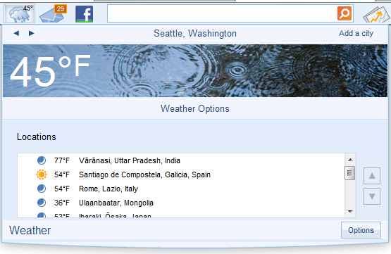

*Figure: Wing showing side direction when user presses Options button*

#### If not used, stop polling

Design your app to notice when the user has not opened the app for an extended period. To save user and server resources in this case, stop periodic data polling. Periodic polling can resume when the user re-opens the app.

### Avoid these design mistakes

Bing Bar apps can use HTML, JavaScript, and CSS to implement engaging user experiences. While designing a Bing Bar app user interface, remember that the Bing Bar app wing is not a full-featured web browser. Many concepts that work within full browsers do not translate into useful user interfaces within Bing Bar apps. Try to avoid these design mistakes.

#### Don’t add back buttons

Apps are not mini-web sites. Avoid navigation schemes that require a 'back' button to return to a previous view in your app’s wing.

#### Don’t use breadcrumbs

Bread crumb navigation works on the web but is not appropriate for Bing Bar apps. Bing Bar apps should not have complex information architectures. A typical app consists of a single hub view supported by a few secondary views. In this example, the user might use a close button in the wing to return from a satellite view to the main hub view.

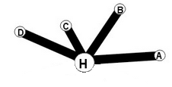

*Figure: Hub View*

The following diagrams represent inappropriate wing UI structures.

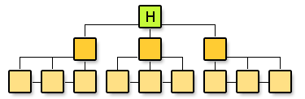

*Figure: Hierarchy (avoid)*

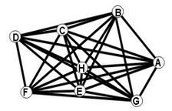

*Figure: Complicated cross linking of UI views (avoid)*

#### Limit wizards

If your app requires a wizard for initial configuration, consider these common sense guidelines:

* Avoid designing a wizard that requires more than two steps. Bing Bar apps are modeless and it's easy to a user to get distracted and click away, losing their place in the wizard.
* Try to limit each wizard panel to one logical task.
* Make the wizard a special case of your app’s options panel or, if possible, part of the first-run experience so the user only encounters it once. It’s important to remember that toolbars can suffer from relatively engagement. Anything that reduces setup time and additional clicks helps ensure the success of your app.

#### Don’t provide a multiple sets of tabs, a wall of buttons, or an “accordion” menu

The value of an app needs to be apparent the first time the user clicks the app’s feature button. Avoid an interface design that presents the user with a list of features exposed via a tree control or an accordion menu control. A Bing Bar app needs to suggest its value on first glance. Choose an initial view that is immediately engaging and somewhat self-explanatory. Don't present the user with a list of options or navigation choices that require interaction. Craft the initial experience and let the user find other options by necessity.

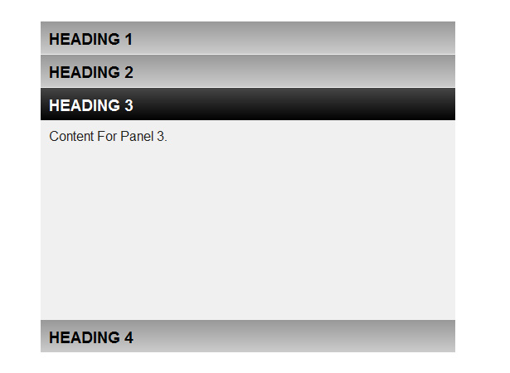 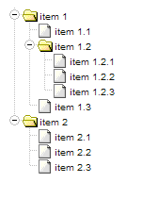

*Figure: Accordion menu and tree control (avoid)*

#### Don’t include splash screens

If possible, avoid splash screens that upsell the user on the app, especially if they require user interaction. An authentication screen may be an exception. You can show a splash or welcome screen the first time the user opens your app. Don’t show it every time. If your app fetches data when it launches, display cached data if possible, and inform the user that the app is fetching updates.

#### Don’t require horizontal scrollbars in app UI

Don’t show horizontal scrollbars for content whose width does not fit in the wing. If necessary, you can use vertical bars to show app content and UI, or try a carousel design where arrows at the left and right ends let the user spin through a palette of options.

#### Don’t use too many tabs in the header

If your app relies on multiple tabs to navigate between content (for example, a news app with many categories), avoid showing more than three tabs in the wing header. Multiple tabs might not scale well in the fixed-width wing without a horizontal overflow control, which can cause localization problems. Ideally, your app will avoid tabs altogether by determining a more engaging way to make your content navigable. You can also scale vertically by displaying tabs vertically in the wing and specifying a taller wing height at design time.

#### Don’t use a pop-up modal dialog box

If your app requires a modal interaction, don't display a pop-up dialog box. Instead, use a slide-down pane as you see in the Options window for most apps.

#### Don't use an iFrame (except for local Flash)

It is possible to host an iFrame element to a remote web site in your wing, but the result won’t meet user expectations for Bing Bar apps. Bing Bar hosts highly engaging interactive apps. Pages hosted in an iFrame are less responsive, report errors inadequately, and face cross-domain calling restrictions. More importantly, Bing Bar is a client-side app platform, and should not be used as a miniature web browser for hosting web pages. You can use an iFrame to host a Flash app if all code and content for the Flash app resides on the local computer.

***Don’t show the sad robot if your app can handle an error***

For unhandled exceptions, the Bing Bar displays a general error message called the sad robot. Your app should only display the sad robot if it cannot handle the error condition and display an appropriate message to the user within the app. Don’t show the sad robot error for data retrieval failures, authentication errors, and other common error scenarios.

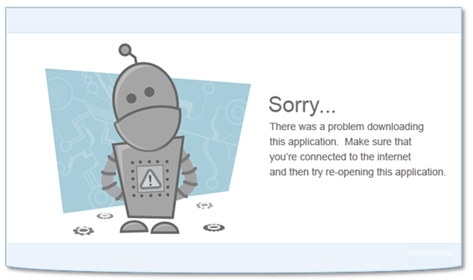

*Figure: Sad robot error*

### Accessibility

Bing Bar apps attempt to comply with MATS (Microsoft Accessible Technology Standards) 1.0 Level 2. This standard meets WCAG 2.0 Level AA and all Section 508 requirements. Developers of apps that will not meet portions of the MATS 1.0 Level 2 standard must tell the Bing team which standards they will not meet.

Accessibility standards require apps consider these details.

#### Support high contrast user interfaces

Examine user interfaces in Windows high-contrast black and high contrast white themes. If possible, avoid relying solely on images to convey vital information, as images might not be visible in high contrast modes. You don’t have to provide high contrast versions of button icons and other symbol graphics, but avoid using graphics for arrow buttons and other essential navigation controls.

#### Accept default focus state

Because Bing Bar runs in Internet Explorer 7 compatibility mode, apps cannot use CSS pseudo-classes to override the appearance of a UI element’s default focus state. Controls that have the keyboard focus include a dotted line some find unappealing. This visual cue of focus state helps impaired users to determine that a control has focus.

#### Provide keyboard access and test tab order

User interfaces should be navigable without a mouse using the Tab key, the Spacebar, Enter, and arrow keys. A tab sequence should start at the top of the UI and work its way down. Users should be able to use the arrow keys to navigate and use collections of similar UI elements, such as items in a list. Test all user interfaces to assure usability with little or no mouse activity.

#### Implement space bar to click

In Windows, pressing the space bar clicks a UI element, and pressing the Enter key only clicks the default button of a dialog. Bing Bar toolbar buttons and wing UIs are not dialog boxes and do not define a default command button. For buttons anywhere in Bing Bar, Enter should behave like the Spacebar to cause an element click. For other UI elements, the Spacebar is a click, while Enter has no effect.

#### Include component names for screen readers

UI elements should have component names. Component names enable a visually impaired user with a screen reader to navigate the UI. Keep the component names short. For example, call a refresh button *refresh* rather than *refresh button*. Bing Bar apps seek to simplify and expedite common tasks for all users, including visually impaired users. At minimum, use Microsoft Narrator to examine your app’s narrated user experience.

#### Support content at high dots-per-inch settings

Many new computers are pre-set to 120% zoom to accommodate high resolution monitors. Your app should look good at 120% and 150%, and should operate at 200% without corruption. Images and other graphics can stretch, but avoid designs that will leave gaps when zoomed, and avoid anchoring content to one side of the UI.

#### Animated content over five seconds must be stoppable

If a wing contains animation that runs more than 5 seconds, give users the option to turn this animation off.

### Internationalization and Marketization

Microsoft localizes Bing Bar for 66 language-market groups. You can specify which of these markets your app ships to, and you can customize your app in each market. Microsoft will translate text in your en-us (English-USA) locStrings.js file and appmanifest.xml file into translated files for the markets where you ship. Contact bxcintl@microsoft.com to coordinate handoff and completion dates for translations. A complete list of language-market groups appears in *Appendix B: Language-Market Groups*.

#### Marketization

In addition to language translation, your app can localize settings for each market by providing localized settings.js files. For example, to specify a different URL for users in Japan, specify the URL in a key-value pair within settings.js, and provide a ja-jp/settings.js with a different URL in the key-value pair for Japanese users. Changes to settings.js files can be deployed more easily than app updates, so consider storing control parameters that might need tuning in your settings.js file.

## Bing Bar App Components

The Bing Bar uses the same horizontal band as a traditional toolbar. However, with the centered layout, the toolbar looks different, and the buttons and functionality launch rich web apps instead of pages on remote web sites. The goal of the Bing Bar is to be an engaging app bar, where the buttons launch an app wing at the center of the user's attention.



*Figure: Bing Bar*

### App buttons

A Bing Bar app button can show dynamic images that inform the user. Button imagery should change to reflect app state. The weather app is a classic example, showing a sun behind clouds to illustrate conditions in a glance. Button images are highly visible and should help the user identify the app and its function. Microsoft’s design team can advise you on designing icons that illustrate your app or app states.

#### Button state indicators

An app can also overlay a smaller graphic or a very small amount of text in the upper-right corner of the button to show more information about app state. A text overlay can include transparent, non-urgent (orange), or urgent (red) background coloring. Most apps should include a non-urgent text overlay that says “new” on the first few app runs. The infotip and wing should show more information about the meaning of state indicators that appear on the app button. For example, the weather app uses this indicator when there is an important weather advisory in effect for the user’s location.

##### Green lock during authentication

When your app displays a sign-in screen, overlay a green lock indicator on the button. The green lock overlay provides a small measure of anti-phishing mitigation because it connects the toolbar chrome to the app. A web page pretending to be an app cannot modify button states. Note the green lock on the Facebook app button that appears when the authentication UI is showing.



*Figure: Green lock during authentication in Facebook app*

### Infotips

App buttons can communicate more detail about app state through a rich tooltip called an *information tip*, or *infotip*. An infotip appears when the mouse hovers over the app button.

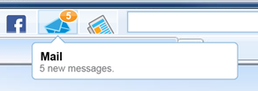

*Figure: Mail button with state indicator and infotip*

An infotip provides a short but meaningful description of what is waiting for the user in the app. Infotips should explain the meaning of visual cues provided by button state indicators. The default infotip before the first run of an app should contain a general statement of the app value. The first infotip line shows the app name. Below the app name up to two brief lines of descriptive information about the current app state should appear. If you’re using an indicator, the second line of the infotip should clarify what the indicator means. For example, the mail app indicator shows a number and its infotip explains what the number means.

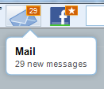

*Figure: Button state indicator with infotip*

### Alerts

An alert is a popup notification that appears below the Bing Bar search box. Alerts can keep the user aware of topics they care about in real time, educate the user about features related to an app or the current browser session, and help users stay connected to their personal services.

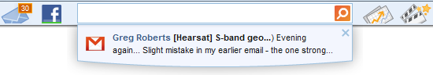

*Figure: Alert from mail app*

Alerts contain a 24x24 pixel icon that is probably similar to the button icon. The app button should reflect the state or event that triggered the alert as long as it still applies. Recent alerts should also appear within the wing content to help the user catch up on activity. All alerts open directly below the search box.

There are four types of successful alerts:

1. Alerts containing information from the user’s personal services help them stay connected. For example, an alert might inform the user of a new friend request within Facebook.
2. Alerts containing information the user would like to stay on top of. For example, breaking news from the news app, or fresh sports scores, perhaps based on the user’s history of sports inquiries.
3. Alerts containing information that is relevant to the current web page or current browsing session. For example, an alert can offer deep links into a web site.
4. Alerts containing information that promotes a feature that may interest the user based on observed web activity. For example, an alert can direct the user to the mail app when the user navigates to gmail.com.

Alerts can text contain buttons, or the entire alert window can click through to a wing or web page. Alerts should only be clickable when a click can show the user **more** information, not the same information that already appeared in the alert. Alerts can be tethered to only fire while the user is active in specific browser sessions, or at a specific web address. Alerts are subject to throttles. For details, see the bingclient.ui.notifications namespace reference.

### Wings

The wing is the main app canvas.

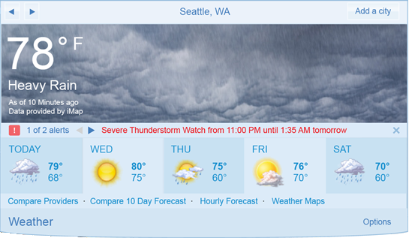

*Figure: App wing for the weather app*

Wings provide a lightweight way to access simple information without having to load a full web page. Wings are smaller than full browser windows. Wing width is fixed, while its height can change at runtime if necessary. Its smaller size forces apps to implement simpler designs. When the task warrants a full browser, the app can close its wing and transfer the user to a full web page. A wing opens when the user presses the app button, and closes when the user concludes the wing session or when focus leaves Internet Explorer. An app can contain many views within a wing.

#### Wing size

All app wings are 550 pixels wide, including the wing frame. You can vary the height but do not exceed 440 pixels as your wing will not fit on low-resolution displays.

#### Common wing components

Wings contain optional and required components.

##### Wing header

Your app can provide a header in its wing. You are not required to include a header, and this SDK does not provide sample code for headers. Add a header only if it makes sense for your app.

##### Wing footer

A wing must include a footer, provided to apps by source code in shared\footer.js. The footer includes a title, and can include an Options button. The title should match the app title in the infotip, and can be a hyperlink to a parent web site. Icons or logos in the footer are not allowed.



*Figure: Footer with Options button*

When pressed, the Options button provides a visual transition to your app settings user interface, and the Options button becomes a Close button. The user interface for app settings is modeless, and changes commit immediately. If the user leaves an app settings page, the Close button is pressed implicitly, so the user will not return to the app settings page when returning to the app.

##### Cached content and load delays in the wing

Apps should avoid showing a blank wing. Cached content can prevent a blank wing, and a timestamp can make users aware when the wing is showing cached content. In the weather app, when there is no good cached content and the app needs to fetch data to generate the UI, the app shows a load delay indicator.

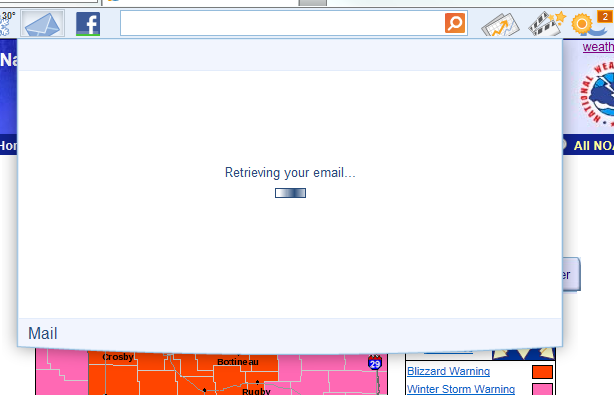

*Figure: A load delay indicator during a global delay*

When an app cannot populate its user interface because it is waiting on remote data or calculations, it should show a load delay indicator in the center of the wing. When an app can show content or user interface elements while waiting for a remote data or calculations, it should show a load delay indicator in the footer of the wing, where the Options or Close link typically appears.



*Figure: Load delay indicator when interface or content remains available during delay*

## Appendix A: Color Palettes

This key shows the CSS styles used by Bing Bar apps.

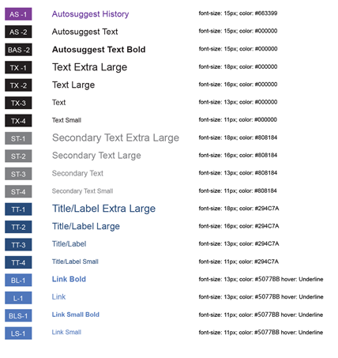

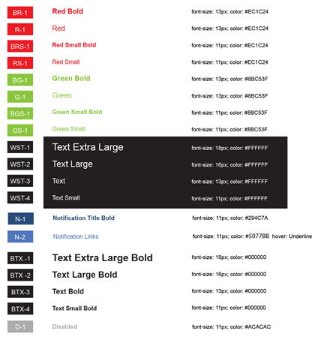

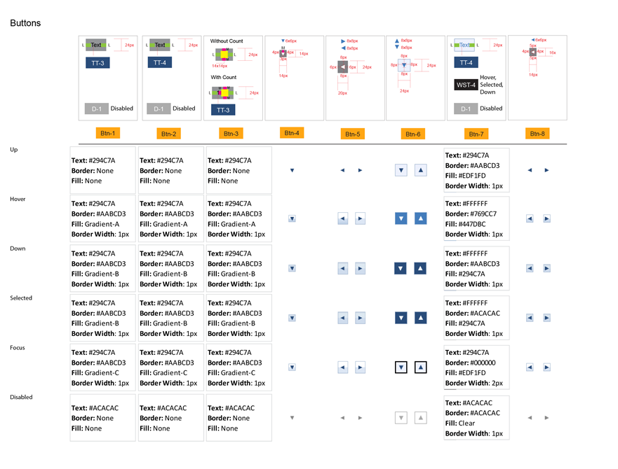

## 

## Appendix B: Language-Market Groups

This table lists language-market groups where Bing Bar apps can designate availability and localize.

|  |  |  |
| --- | --- | --- |
| **Language** | **Country** | **Language-Market Code** |
| French | Arabia | fr-145 |
| English | Arabia | en-145 |
| Arabic (Complex Script/BiDi) | Arabia | ar-145 |
| Spanish | Argentina | es-ar |
| English | Australia | en-au |
| German | Austria | de-at |
| Basque | Spain | eu-es |
| Dutch | Belgium | nl-be |
| French | Belgium | fr-be |
| Portuguese (Brazil) | Brazil | pt-br |
| Bulgarian | Bulgaria | bg-bg |
| English | Canada | en-ca |
| French | Canada | fr-ca |
| Catalan | Spain | ca-es |
| Spanish | Chile | es-cl |
| Chinese (Sim) (IME) | China | zh-cn |
| Croatian | Croatia | hr-hr |
| Czech | Czech | cs-cz |
| Danish | Denmark | da-dk |
| Estonian | Estonia | et-ee |
| Finnish | Finland | fi-fi |
| French | France | fr-fr |
| German | Germany | de-de |
| Greek | Greece | el-gr |
| Chinese (Trad) (IME) | Hong Kong | zh-hk |
| Hungarian | Hungary | hu-hu |
| English | India | en-in |
| Gujarati | India | gu-in |
| Hindi | India | hi-in |
| Kannada | India | kn-in |
| Malayalam | India | ml-in |
| Marathi | India | mr-in |
| Tamil | India | ta-in |
| Telugu | India | te-in |
| English | Indonesia | en-id |
| Indonesian | Indonesia | id-id |
| English | Ireland | en-ie |
| Hebrew (Comp Script/BiDi) | Israel | he-il |
| Italian | Italy | it-it |
| Japanese | Japan | ja-jp |
| Korean | Korea | ko-kr |
| Spanish | LATAM ROR | es-419 |
| Latvian | Latvia | lv-lv |
| Lithuanian | Lithuanian | lt-lt |
| English | Malaysia | en-my |
| Malay (Malaysia - Brunei Darussalam) | Malaysia | ms-my |
| Spanish | Mexico | es-mx |
| Dutch | Netherlands | nl-nl |
| English | New Zealand | en-nz |
| Norwegian - Bokmål | Norway | nb-no |
| English | Philippines | en-ph |
| Polish | Poland | pl-pl |
| Portuguese (Portugal) | Portugal | pt-pt |
| Romanian | Romania | ro-ro |
| Russian | Russia | ru-ru |
| Serbian (Latin) | Serbia | sr-latn-cs |
| Serbian (Cyrillic) | Serbia | sr-cyrl-cs |
| English | Singapore | en-sg |
| Slovak | Slovakia | sk-sk |
| Slovenian | Slovenia | sl-si |
| English | South Africa | en-za |
| Spanish | Spain | es-es |
| Swahili | Kenya | sw-ke |
| Swedish | Sweden | sv-se |
| French | Switzerland | fr-ch |
| German | Switzerland | de-ch |
| Chinese (Trad) (IME) | Taiwan | zh-tw |
| Thai | Thailand | th-th |
| Turkish | Turkey | tr-tr |
| English | UK | en-gb |
| Ukranian | Ukraine | uk-ua |
| English | US | en-us |
| Spanish | US | es-us |
| Vietnamese | Vietnamese | vi-vn |
| English | World-wide - English | en-001 |
| Spanish | World-wide -Spanish | es-001 |